**ALESSANDRO PRAMUDHITA PUTRA SETYAWAN**

**VSGA GELOMBANG 15**

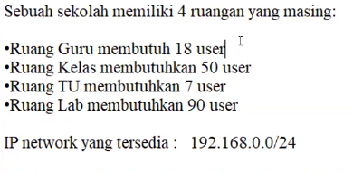**JNA-1**

# **Studi Kasus**

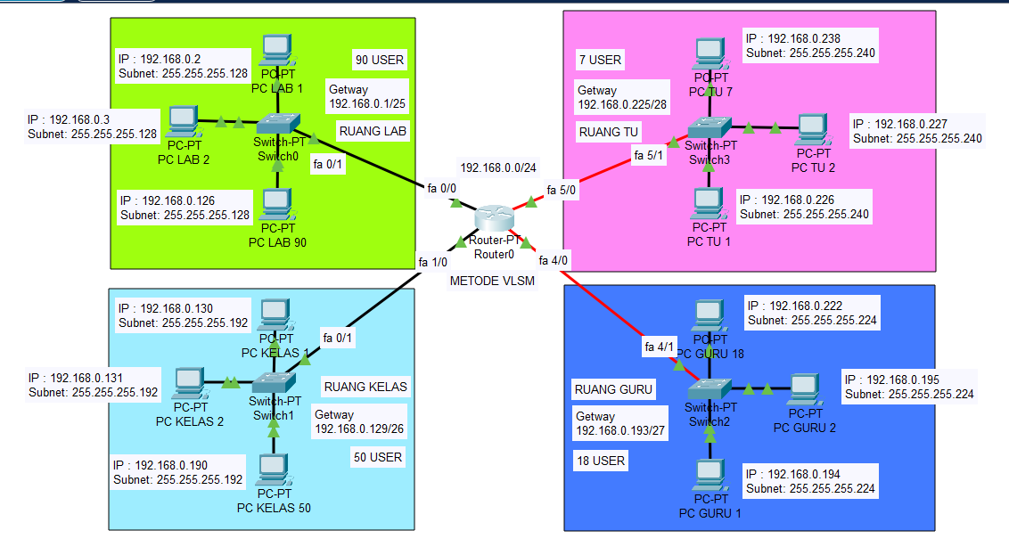

# **Perhitungan VLSM**

* Sebuah sekolah dengan IP Network **192.168.0.0/24** (**Class C**) mempunyai subnet dengan kebutuhan berdasarkan jumlah host, yaitu Ruang Guru 18 User, Ruang Kelas 50 User, Ruang TU 7 User, dan Ruang Lab 90 User.
* **INGAT!! n pada rumus adalah Jumlah 0 yang ada pada oktet keempat..**
* **Analisa** 192.168.0.0/24 berarti kelas C dengan prefix /27, maka subnet masknya

11111111.11111111.11111111.00000000 (255.255.255.0).

Secara keseluruhan terlihat untuk melakukan hal tersebut di butuhkan 8 bit host → 2n – 2 = Jumlah Host Per Subnet → 28 – 2 = 254 host, sehingga

Ruang Guru = 18 host = 192.168.0.0/24 → 254 host (236 host not used).

Ruang Kelas = 50 host = 192.168.1.0/24 → 254 host (204 host not used).

Ruang TU = 7 host = 192.168.2.0/24 → 254 host (247 host not used).

Ruang Lab = 90 host = 192.168.3.0/24 → 254 host (164 host not used).

* **Buat Urutan Berdasarkan Jumlah Host Terbanyak**

Ruang Lab = 90 host (1)

Ruang Kelas = 50 host (2)

Ruang Guru = 18 host (3)

Ruang TU = 7 host (4)

* **Menentukan Bit Net / Prefix yang Paling Efektif**

Ruang Lab = 90 host = 32 - n = Prefix Efektif → 32 - 7 = 25 → /25

Ruang Kelas = 50 host = 32 - n = Prefix Efektif → 32 - 6 = 26 → /26

Ruang Guru = 18 host = 32 - n = Prefix Efektif → 32 - 5 = 27 → /27

Ruang TU = 7 host = 32 - n = Prefix Efektif → 32 - 4 = 28 → /28

* **Menentukan Subnet Mask**

Ruang Lab = Bit Net / Prefix = /25 = 128 → 255.255.255.128

Ruang Kelas = Bit Net / Prefix = /26 = 192 → 255.255.255.192

Ruang Guru = Bit Net / Prefix = /27 = 224 → 255.255.255.224

Ruang TU = Bit Net / Prefix = /28 = 240 → 255.255.255.240

* **Menentukan Total Host yang Dapat Digunakan (Host Range)**

Ruang Lab = 90 host = 2n – 2 = Total Host → 27– 2 = 126 Host (36 not used)

Ruang Kelas = 50 host = 2n – 2 = Total Host → 26– 2 = 62 Host (12 not used)

Ruang Guru = 18 host = 2n – 2 = Total Host → 25– 2 = 30 Host (12 not used)

Ruang TU = 7 host = 2n – 2 = Total Host → 24– 2 = 14 Host (7 not used)

* **Menentukan Blok Subnet**

Ruang Lab = 90 host = 256 - Prefix → 256 - /25 → 256 - 128 = 128

Ruang Kelas = 50 host = 256 - Prefix → 256 - /26 → 256 - 192 = 64

Ruang Guru = 18 host = 256 - Prefix → 256 - /27 → 256 - 224 = 32

Ruang TU = 7 host = 256 - Prefix → 256 - /28 → 256 - 240 = 16

**Sehingga Blok Subnetnya Menjadi :**

Ruang Lab = 90 host = 192.168.0.0/25

Ruang Kelas = 50 host = 192.168.0.128/26

Ruang Guru = 18 host = 192.168.0.192/27

Ruang TU = 7 host = 192.168.0.224/28

* **Subnet Map**

|  |  |  |  |
| --- | --- | --- | --- |
| **Subnet Name** | **IP Network** | **IP Range** | **IP Broadcast** |
| Ruang Lab | 192.168.0.0 | 192.168.0.1 - 192.168.0.126 | 192.168.0.127 |
| Ruang Kelas | 192.168.0.128 | 192.168.0.129 - 192.168.0.190 | 192.168.0.191 |
| Ruang Guru | 192.168.0.192 | 192.168.0.193 - 192.168.0.222 | 192.168.0.223 |
| Ruang TU | 192.168.0.224 | 192.168.0.225 - 192.168.0.238 | 192.168.0.239 |